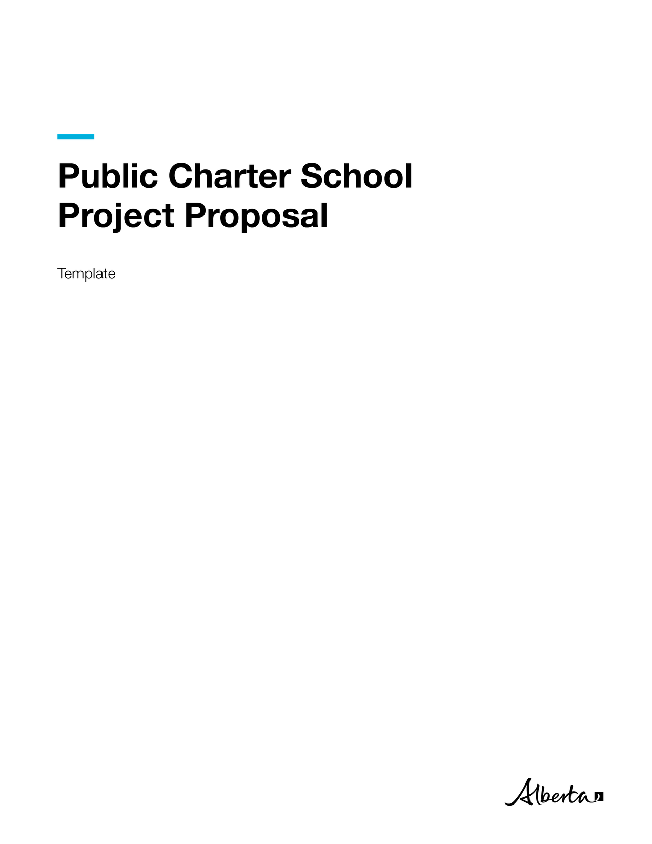
Public Charter School Project Proposal Template | Education
© 2024 Government of Alberta | November December 3, 2024
This publication is available online at Planning and building schools | Alberta.ca



Contents
Needs/Opportunities 1
Reason for Proposal 1
Context 1
Current State 1
Ideal State 1
Risk Analysis 1
Site Readiness 1
Critical Deadlines 2
Potential Solutions 2
Comparative Analysis 2
Options Identification 2
Operational Adjustment Strategies 2
Planning Documents Schedule and Costs 3
Milestones and Schedule 3
Funding Request 3
Project Proposal Review Process 3
Project Delivery Consultation 3
Authorship 4

Needs/Opportunities

Reason for Proposal
Provide a brief description of the needs/opportunities that have prompted this proposal. Examples include program requirements, change in legislation, change in lease agreement, Government of Alberta asset opportunity, Government of Alberta cost savings, health and safety, functionality, etc.
{Insert text here}

Context

Describe the social, historical, or other meaningful context relating to the need/opportunity.
{Insert text here}

Current State
Understanding the current situation is essential to developing a needs analysis as it provides a baseline or status quo measurement. In this section, describe what is happening without drawing any conclusions with regard to specific solutions. Cite the data used to track and report on the current state.
{Insert text here}

Ideal State
Describe the difference between the current operational state and the ideal operational state. Using quantifiable and specific measures, define the desired operational state to be achieved. If the intent is to improve existing functions/services, clearly identify the savings in staffing, costs, time, quality, and other relevant measurements, etc
{Insert text here}

Risk Analysis
Identify the risks associated with not taking action to address the need/opportunity. Discuss the likelihood of the occurrence, the level of the impact, and the data used to support the risk analysis.
To add a new row, right-click in the table, then click ‘insert’. Select ‘Insert above’ or ‘Insert below’. To delete a row, highlight the row to be deleted, press ‘backspace’ key.
Risk | Probability | Impact | Data
[Risk] | [Probability] | [Impact] | [Data]

Site Readiness
Identify the site of the project using an address, coordinate, and/or a building name. Discuss whether the school jurisdiction has acquired the land title, whether there has there been consultation with the municipality, if the municipality provided confirmation of the land title acquisition in a letter, and if the zoning of the site is appropriate for a school. Explain whether the site is suitable for a school and any risks associated with the school site, such as: being situated on a floodplain, abandoned wells, near major roadways, near powerlines, easements, and utility rights-of-way. Is the size of the site appropriate for a school to accommodate the building, parking requirements, play fields, playgrounds, parent/bus drop-off zones? Is the site serviced appropriately for a school with confirmed available service capacities for the facility?
{Insert text here}

Critical Deadlines
Identify any factors that necessitate addressing the need/opportunity by a specific date. Examples include the expiration of a lease and a deadline for meeting legislated requirements.
{Insert text here}

Potential Solutions

Comparative Analysis
Identify what other organizations (internal and external) and school jurisdictions have done to address a similar need/opportunity.
To add a new row, right-click in the table, then click ‘insert’. Select ‘Insert above’ or ‘Insert below’. To delete a row, highlight the row to be deleted, press ‘backspace’ key.
Organization/Jurisdiction | Solution
[Organization Name] | [Description]

Options Identification
Propose viable options to address the identified need/opportunity. This is a preliminary and high-level exploration of possible solutions. A more thorough and evidence-based options analysis is required in the business case.
To add a new row, right-click in the table, then click ‘insert’. Select ‘Insert above’ or ‘Insert below’. To delete a row, highlight the row to be deleted, press ‘backspace’ key.
Option Name | Description
[Option Name] | [Description]

Operational Adjustment Strategies
Discuss how the need/opportunity can be addressed through operational adjustments, should the capital funding request not be approved.
{Insert text here}

Planning Documents Schedule and Costs

Milestones and Schedule
List the major milestones and completion dates for the planning documents, should the submission be approved.
To add a new row, right-click in the table, then click ‘Insert’. Select ‘Insert above’ or ‘Insert below’. To delete a row, highlight the row to be deleted, press ‘Backspace’ key.
Milestone | Estimated Completion Date
Deliverable | Date

Funding Request
Identify how much capital funding is required for the proposal and provide an explanation of how the cost was derived.
For all project requests, an independent cost estimate should be included as an attachment.
If the project involves purchasing an existing facility, please provide an independent market assessment.
Phase | Capital Plan Funds Request | Rationale
Planning | [Enter $ Amount] | [Rationale]
Acquisition (if applicable)
Design
Construction

Project Proposal Review Process

Project Delivery Consultation
Your capital planning manager should review the proposal before submission. Please confirm that you have been in contact with Education.

To add a new row, right-click in the table, then click ‘Insert’. Select ‘Insert above’ or ‘Insert below’. To delete a row, highlight the row to be deleted, press ‘Backspace’ key.
Ministry and Branch | Name | Comments | Date
[Ministry, Branch] | [Name, Title] | [Enter Comments] | [dd/mm/yyyy]

Authorship
List the author and reviewers of the proposal.
Role | Name | Comments | Date
Prepared by: | [Name, Title] | [Enter Comments] | [dd/mm/yyyy]
Reviewed by: | [Name, Title] | [Enter Comments] | [dd/mm/yyyy]
Reviewed by: | [Name, Title] | [Enter Comments] | [dd/mm/yyyy]

