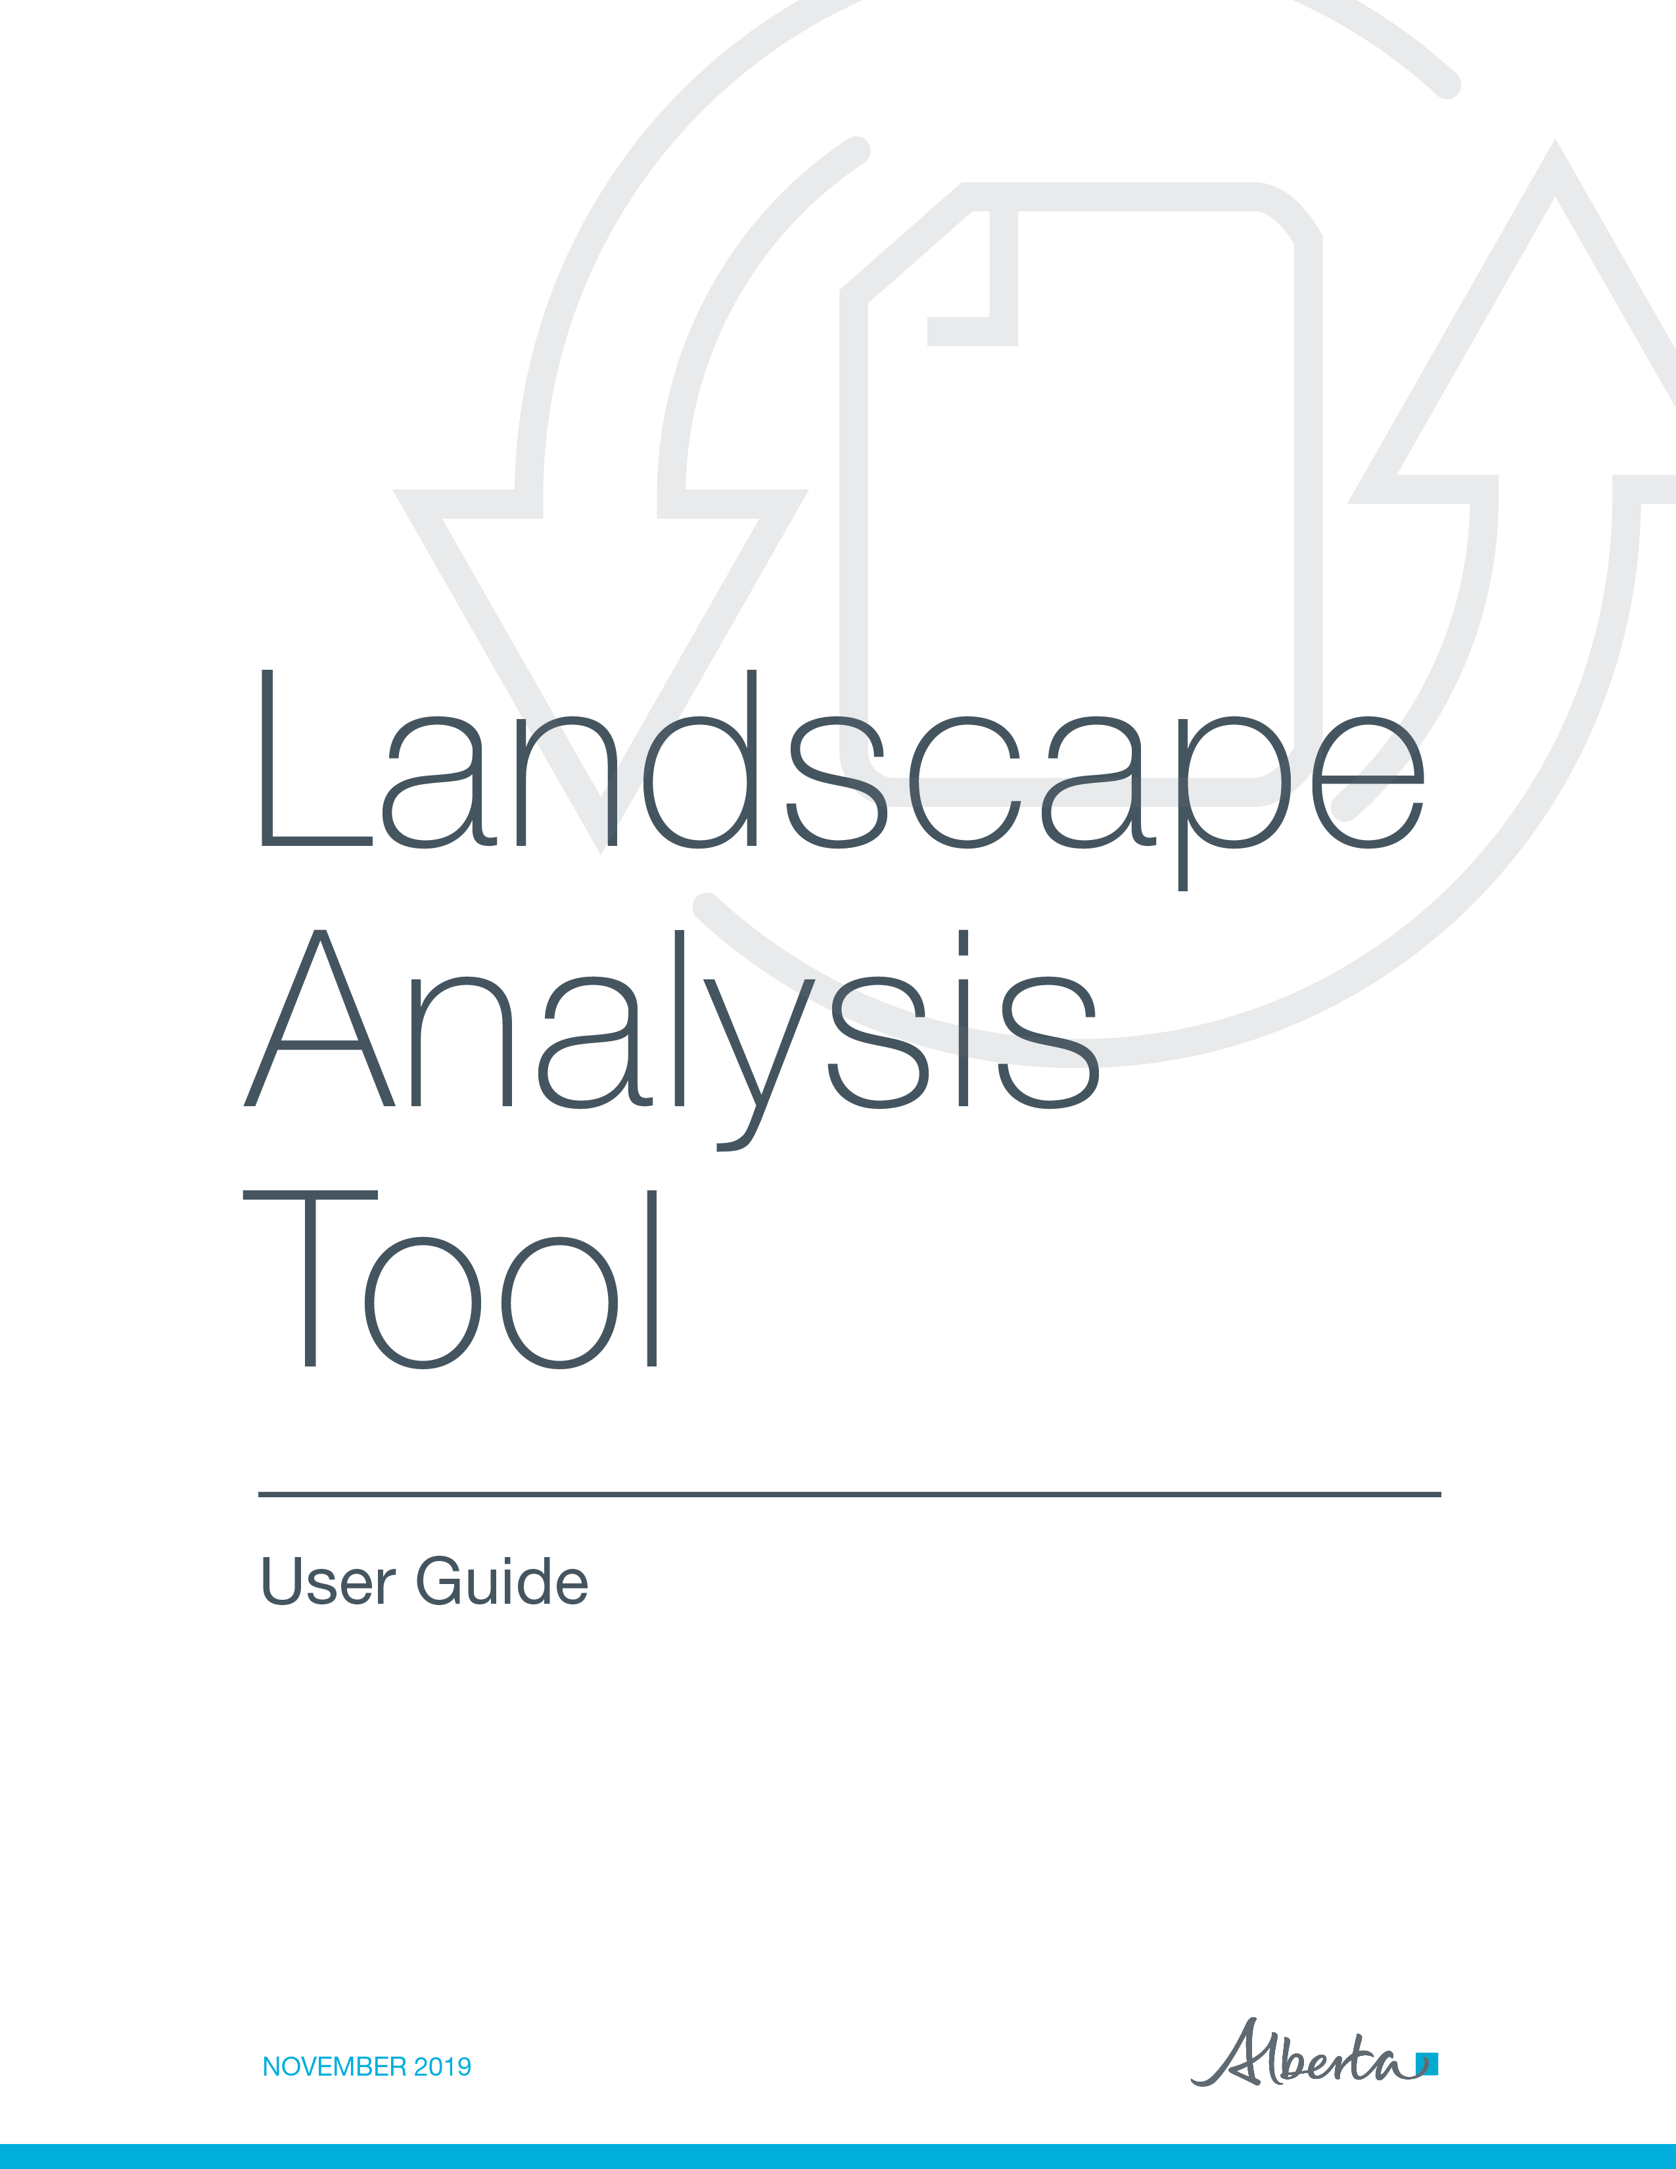
Environment and Parks, Government of Alberta
Date of publication: November 1, 2019
Title of publication: Landscape Analysis Tool User Guide
https://www.alberta.ca/electronic-disposition-system-overview.aspx
© 2019 Government of Alberta

Disclaimer

In this disclaimer provision:
“Crown” means Her Majesty the Queen in right of the Province of Alberta.
“Minister” means the Minister responsible for the department of Alberta Environment and Parks.
“Their employees” means and includes each, any and every officer, employee, servant and agent of either or both of the Crown and the Minister and without limiting the generality of the foregoing, and includes employees of the Crown and the Minister employed in Alberta Environment and Parks.
“LAT” means Landscape Analysis Tool and all programs, hardware, documentation, functions and services forming a part thereof or associate therewith.
The Crown, the Minister and their employees and the contractors and technical advisors of the aforesaid:
(a) Make no warranty or representation, whether expressed or implied, to any person with respect to this material or documentation of EDS or as to the service, performance, quality, merchantability or fitness of any part of the aforesaid for any purpose; and
(b) Shall not be liable for any action, damages or claims, whether occasioned by negligence or otherwise, that any person, user, subscriber or any employees of the aforesaid may hereafter have, allege or become entitled to (including but not limited to any claim of third-party contribution of indemnity, any economic or moral loss, or direct, immediate, special, indirect or consequential damages which do, may, or are alleged to arise as a result of:
(i) The use of this material or documentation or LAT or any service connection therewith; or
(ii) Any error or omissions in data or any loss or partial loss of data or incomplete retrieval of information, even if any or all of the Crown, the Minister or their employees were advised of the possibility of such risk, action, claims or damages, including damages sustained or actions brought by third parties and claims made against the subscriber by third parties.
The entire risk of loss relating to or associated with the quality and performance of LAT and any product and results thereof shall be assumed by the subscriber and by any other users of LAT.

Acknowledgement
Portions of the LAT were constructed using licensed GeoCortex Essentials technology, developed by Latitude Geographics Group Ltd. Portions of this LAT User Guide made liberal use of the contents of the GeoCortex Essentials On-line Help and Tutorial System for content. We greatly appreciate the ability to use this information and acknowledge their contribution to this document.

Table of Contents

1 Introduction 9
1.1 LAT Overview 9
1.2 LAT Features 10
1.3 LAT Report 10
1.4 Getting Help 11
1.5 LAT Use Restrictions 12
2 Quick Start: How do I get LAT Reports for Proposed Activities? 12
2.1 The LAT Report Workflow 12
2.1.1 Entering the LAT URL on your Internet browser. 13
2.1.2 Entering Proposed Activities into LAT 16
Step A - How to upload a shapefile: 16
Step B - Adding proposed activities in LAT using the Draw LAT Activity tool 24
3 LAT User Interface 27
3.1 LAT Toolbars 28
3.1.1 Navigation 29
3.1.2 LAT Tasks 33
3.1.3 Go To Location 36
3.1.4 Annotate and Print 39
3.1.5 Analysis 45
3.1.6 Help 49
3.2 Side Pane 49
3.3 Map Window 50
3.4 Magnification Controls 51
3.5 Toolbar icon Shortcut 51
3.6 Coordinates Widget 51
3.7 Scale Input Box 51
3.8 Quick Action button 51
3.9 Bookmarked Locations 52
4 Troubleshooting LAT Report Error Messages 52
4.1 Non-Admin Areas 52
4.2 Invalid Activity Code 53
4.3 Out of Province 54
4.4 Peat Extraction not allowed 55
Appendix A - LAT Shapefile Specification for Proposed Activities 56
Introduction: 56
File naming: 57
Map Projection and Datum: 57
Geo-referencing: 58
Proposed Activity Size Limitations: 58
Shapefile Attributes and Attribute Values: 58

Figures

Figure 1 – The LAT Report Workflow 13
Figure 2 - Terms of Use Agreement for LAT 14
Figure 3 - LAT Map Interface/Welcome Screen 15
Figure 4 - Adding a Shapefile 16
Figure 5 - Add Data to Map Dialog box 17
Figure 6 - Browsing to Shapefile location Dialog Box 18
Figure 7 - Shapefile Upload Button 19
Figure 8 - Layer Details Window 19
Figure 9 - Symbolize Data Window 20
Figure 10 - LAT Report icon 21
Figure 11 - LAT Report Contact/Project Information Dialog Box 21
Figure 12 - Generating LAT Report Confirmation Dialog Box 22
Figure 13 - LAT Report Request Email 22
Figure 14 - LAT Report Available Email 23
Figure 15 - Adding Proposed Activity using LAT Editor Tool 24
Figure 16 - Address Navigation 25
Figure 17 - Go to ATS Dialog Box 26
Figure 18 - LAT Viewer controls 28
Figure 19 - "Navigation" Toolbar icons 29
Figure 20 - Identify, Disable Buffering and Identifiable Layers icon on Tools toolbar 30
Figure 21 - Bookmarked Locations Box 31
Figure 22 - Logging into Valtus Imagery 32
Figure 23 - Adding Valtus Imagery 32
Figure 24 - “LAT Tasks” Toolbar icons 33
Figure 25 - Resizing a Proposed Activity 35
Figure 26 - Delete Confirmation window for a Proposed Activity 36
Figure 27 - – Go to Location toolbar 36
Figure 28 - Go To Address Search Field 37
Figure 29 - “Annotate and Print” Toolbar icons 39
Figure 30 - Exporting a Map Image 40
Figure 31 - Drawing Shapes under the Tasks>Point Icon 41
Figure 32 - Snappable Layers 43
Figure 33 - Edit Icon drop down 44
Figure 34 - Analysis Toolbar icons 45
Figure 35 - Plotting a Coordinate 46
Figure 36 - Deleting a Plotted Coordinate 47
Figure 37 - Calculating the Area of a Polygon 48
Figure 38 - Help Toolbar 49
Figure 39 - Active icons on Side Pane 50
Figure 40 - LAT Report Error Screenshot – Non Admin Areas 53
Figure 41 - LAT Report Error Screenshot – Invalid Activity Code 54
Figure 42 - LAT Report Error Screenshot – Out of Province 55
Figure 43 - LAT Report Error Screenshot – Peat Extraction not allowed 56

Tables

Table 1 - Disposition Types 11
Table 2 - Shapefile Attributes and Attribute Values 58

1 Introduction
This version of Landscape Analysis Tool (LAT) is the second release of the LAT software, which integrates more electronic disposition types used by Environment and Parks (AEP).

1.1 LAT Overview
LAT is a web-enabled geospatial tool that allow applicants to plan activities on public land. LAT enables:
- Virtual siting of proposed project activities.
- Identification of operational constraints that may apply to the activity.
- Virtual re-siting or changes to that proposed activity at a landscape level to mitigate concerns prior to application.
- Provides information to help determine if a proposed development might affect historic resources, including archaeological sites, historic structures, indigenous traditional use sites and palaeontological sites.

Historic Resource Application requirement
On page 3 of the LAT report, if Historic Resources Application Required text says yes, then you must apply for a Historic Resources application number from:
- Online Permitting and Clearance System (OPAC)

1.2 LAT Features
The Landscape Analysis Tool:
- Provides a platform for geospatial information for industry and the regulatory body around disposition planning and application.
- Identifies areas requiring higher levels of risk mitigation planning.
- Links to approval standards and operating conditions directly related to a planning activity and location. LAT attaches the appropriate approval standards and operating conditions from the Master Schedule of Standards and Conditions document to a LAT report based on the proposed activity, location, and sensitive layers intersected.
- It can be used to assist in the planning of other proposed activities or Temporary Field Authorizations (TFAs) to manage around identified resource values.
- Uses approximately 60 data layers, divided into two categories of layers:

Base Map Layer – This is a generalized view of key data layers that provide a background setting for the map. This presents the user with details at the provincial extent to help orient to the specific locations.
Operational Layers – These layers provide specific context and detail of key data layers, which can be toggled on or off. Some of these layers pertain to the report processing logic of a user’s proposed activities.

1.3 LAT Report
The Landscape Analysis Tool (LAT) generates a LAT report, which is a system generated PDF document that provides information specific to the proposed site and activity.
The LAT report provides provincial and sensitivity section approval standards and operating conditions that are specific to the proposed activity. The approval standards and operating conditions identified in the LAT report form a part of the disposition document.
The LAT report allows the client to:
- Make informed decisions.
- Adjust the project if desired.
- Apply appropriate standards, conditions or risk mitigation.

1.4 Getting Help
The LAT Support help desk is available Monday to Friday 8:15 a.m. to 4:30 p.m. except on statutory holidays. The system is available from 5:00 a.m. to 11:30 p.m. every day. To report problems, kindly reference the table below.
Disposition Code and Description | Corresponding Regulatory Body and Contact Information
ALR – Aggregate Land Review Request  DLO - License of Occupation  DML - Miscellaneous Lease  DMS - Mineral Surface Lease  DPI - Pipeline Installation Lease  DPL - Pipeline Agreement  EZE - Easement  REA - Rural Electric Association Easement  REC - Recreational Lease  SMC - Surface Material License  SME - Surface Material Exploration  SML - Surface Material Lease  TCL - Tourism and Commercial Recreation Lease  VCE - Vegetation Control Easement | AEP support helpdesk email: EDS.Support@gov.ab.ca  AEP telephone:  780 427-3570 or 780 422-2079  Availability:  Weekdays from 8:15am to 4:30pm, except statutory holidays

Table 1 - Disposition Types

In your e-mail, provide the following:
- steps taken along with screenshots showing values entered
- what happened / what was the error
- what you expected to happen instead

1.5 LAT Use Restrictions
- LAT is limited to the following disposition types: DLO, DML, DMS, DPI, DPL, EZE, REA, REC, SMC, SME, SML, TCL and VCE. LAT reports can also be generated for ALR applications.
- A LAT report, which has been used in support of an Application or an Amendment in EDS, cannot be reused except for where the Application or Amendment was rejected.
- A LAT report generated which is older than 120 days will not be accepted for submission as an attachment for a Public Lands Disposition Application or Amendment in EDS.

2 Quick Start: How do I get LAT Reports for Proposed Activities?

2.1 The LAT Report Workflow
The workflow for generating the LAT report is shown in the diagram below and includes the following basic steps:
- Type in the LAT URL.
- Enter the Proposed Activity locations into the LAT using the “Upload Data” tool, or by drawing a LAT Activity polygon.
- Edit the locations of Proposed Activities where applicable using the (add, move, modify, or delete) icons.
- Enter the Project Information (company name, contact name, email, project name and project description).
- Generate the LAT report(s).
- Receive the LAT report(s) and associated returns by email.
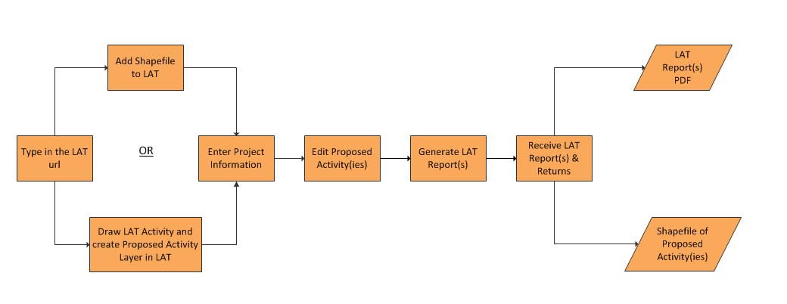
Figure 1 – The LAT Report Workflow

2.1.1 Entering the LAT URL on your Internet browser.
- Landscape Analysis Tool (LAT)
The LAT map viewer uses HTML5 technology and works on most desktop browsers including MS Edge, Internet Explorer, Google Chrome and Mozilla Firefox. The URL is also accessible on mobile devices including Windows, Android and IOS Operating systems.
Once launched for the very first time, you are directed to the “Terms of Use” page. Upon reading the terms and conditions,
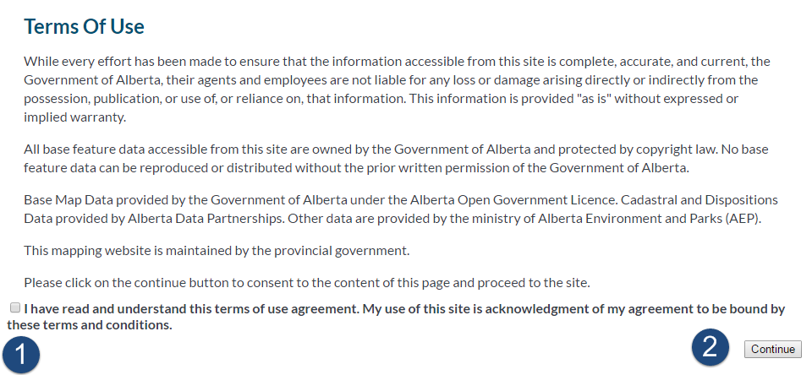
Figure 2 - Terms of Use Agreement for LAT

- Click the checkbox to accept it.
- Click the continue button to proceed to the map viewer.
This launches the LAT Tool within your browser and displays the provincial base map. On the sidebar, a welcome page displays. Read it and close it using the expand/collapse button when you are done to display the Base Map and Operational Data Layers.
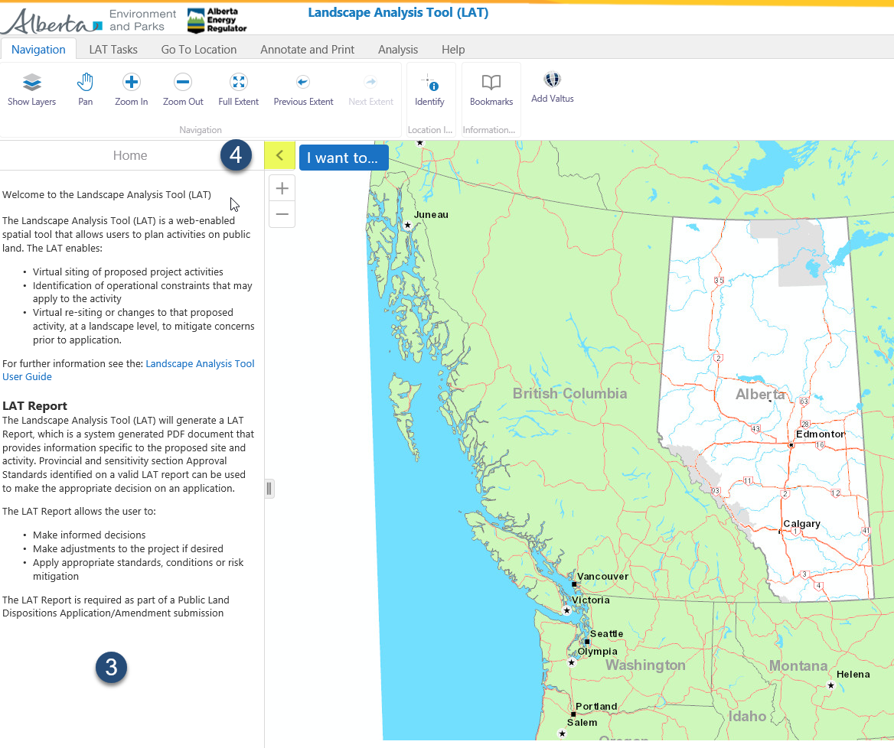
Figure 3 - LAT Map Interface/Welcome Screen

- The LAT Home page displays.
- Use the Expand/Collapse arrow to display or dock the left menu pane.

2.1.2 Entering Proposed Activities into LAT
There are two methods to enter Proposed Activity data into LAT. Data can be entered in through any of these options:
- Uploading a shapefile containing proposed activities;
- Adding proposed activities into LAT using the LAT Editor tool.

Step A - How to upload a shapefile:
***NOTE: LAT requires all shapefiles uploaded to the map viewer to conform to the specifications contained within the link below:
- LAT Shapefile Specification for Proposed Activities
Please refer to this specification to ensure that your shapefile is processed successfully. Failure to comply with this specification may result in an error or invalid LAT reports.
A user who does not have the drafting skills required to produce the shapefile used in generating a LAT report must engage the services of a surveying or environmental company.
Alternatively, you may test your skills with adding the proposed activity (shapefile) using the LAT Editor tool explained in Step B but the caveat with this approach is location accuracies may be compromised thus it must only be utilized as an option for pre-planning purposes and not used for generating LAT reports to be officially submitted to the department.

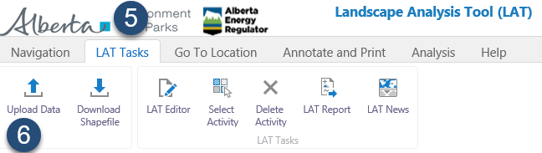
Figure 4 - Adding a Shapefile

- Click on the “LAT Tasks” window pane.
- Select the “Upload Data” Tool from the LAT Tasks pane.
A dialog box ‘Add Data to Map’ displays next. For the purposes of creating a LAT report, the only supported file type is a shapefile (.shp). As a minimum requirement, the following shapefile extensions are mandatory when importing into the map viewer: .shp, .dbf, .shx and .prj shapefile extensions. All other shapefile extensions are optional.
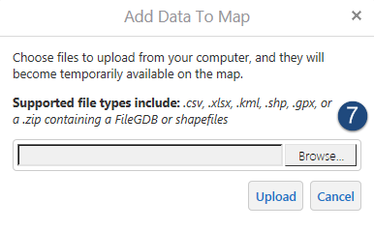
Figure 5 - Add Data to Map Dialog box

- Click on the Browse button.
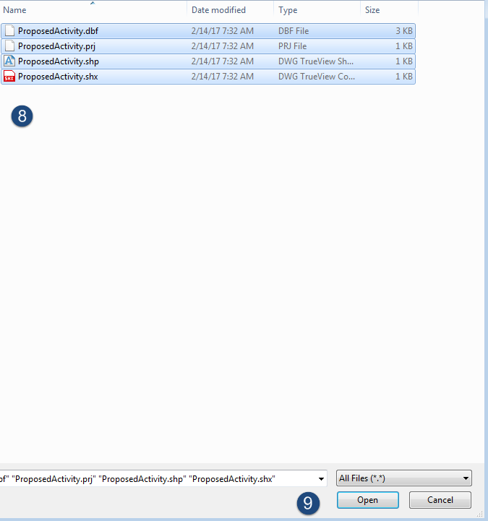
Figure 6 - Browsing to Shapefile location Dialog Box

Browse to the directory of the shapefile.
- Select the shapefile extensions (.dbf, .shp, .shx and .prj) as illustrated above.
- Click on the Open button.
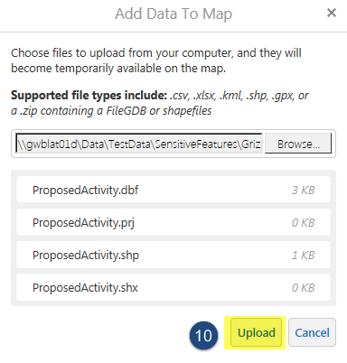
Figure 7 - Shapefile Upload Button

- Click on the Upload button.

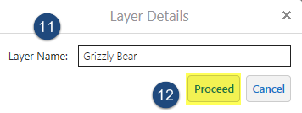
Figure 8 - Layer Details Window

- Type in the name of the proposed activity layer.
- Then click on the Proceed button.

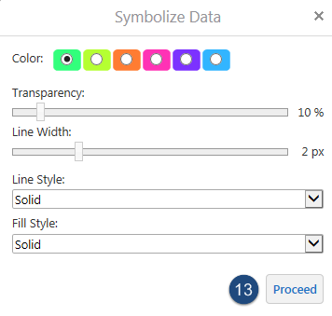
Figure 9 - Symbolize Data Window

The Symbolize Data window allows you to customize the display of your shapefile on the map window. Colour, Transparency, Line Width, Line Style and Fill Style preferences can all be set.
- Click on Proceed to accept all options.
Now, the shapefile is displayed on the map window. To view the shapefile from the layers table of content, click on the Layers icon as illustrated below.

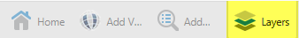

The toolbar is accessible from the bottom of the layer’s table of contents. The table of content / menu pane must be expanded to view the layer list. Information on how to expand this window can be found under Step 4 at:
- Figure 3 – LAT Map Interface/Welcome Screen

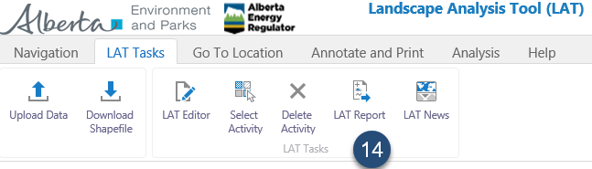
Figure 10 - LAT Report icon

- From the LAT Tasks header on the toolbar, Click on LAT Report.

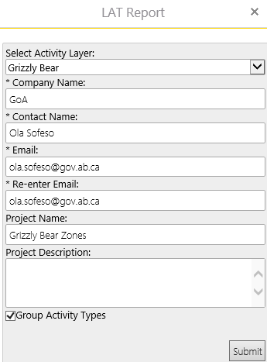
Figure 11 - LAT Report Contact/Project Information Dialog Box

The LAT Report window pops up next - fill in all the required fields. Asterisks indicates mandatory fields. Group Activity Type is only checked where you have multiple polygons/proposed activities with the same activity type on the map viewer you’d like to be listed and downloaded into a single LAT report rather than having them retrieved as separate LAT reports.
Click on Submit to have the LAT report generated.
You should see a message displayed in the upper left window saying …Generating LAT Report.
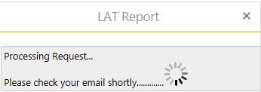
Figure 12 - Generating LAT Report Confirmation Dialog Box

This should take no more than fifteen seconds after which the dialog box returns to the LAT Report Contact/Project Information window. At this point, the LAT report(s) is sent to the email address specified in the LAT Report window and no further action is required.
Two emails are sent to the email address supplied as seen in Figures 13 and 14; the first to arrive is simply a LAT Report Request notification email with a LAT reference number attached.
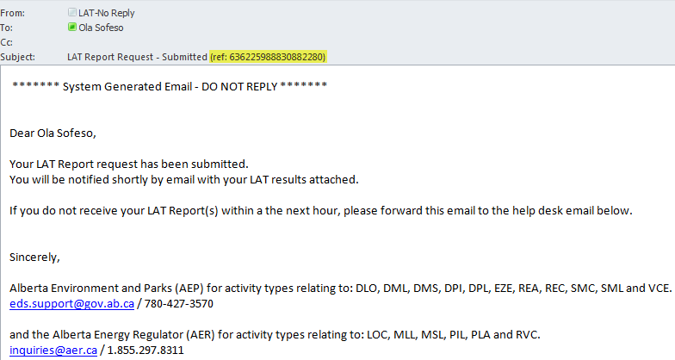
Figure 13 - LAT Report Request Email
The second email contains two attachments, which correspond to the LAT report and a copy of the Proposed Activity (shapefile) uploaded to the LAT viewer.
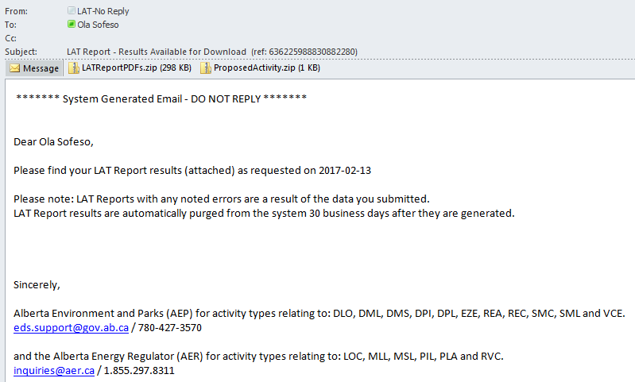
Figure 14 - LAT Report Available Email

Proposed Activity layers added using the Upload Data function could be removed from the LAT map viewer.
To remove the layer from the menu pane, click on the right arrow beside the proposed activity layer indicated here:
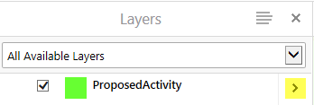
Three options become available which are Zoom to Extent, Zoom to Visible Scale and Remove Layer. To confirm deletion of the layer, click on ‘Remove Layer’.
Only layers imported using the Upload Data icon can be deleted using the ‘Remove’ layer functionality as described above. An alternative means to deleting layers added especially using the LAT Editor Tool can be found in the link below.
- Figure 24 – “LAT Tasks” Toolbar Icons4

- (Deleting Activity icon)

Step B - Adding proposed activities in LAT using the Draw LAT Activity tool

To enter proposed activities, continue as illustrated below.
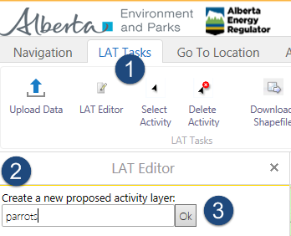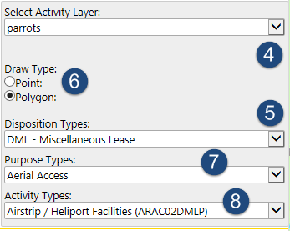
Figure 15 - Adding Proposed Activity using LAT Editor Tool

- Click on LAT Tasks > LAT Editor.
- Enter a name for the new proposed activity layer.
- Click OK.
- Click on the drop down arrow to select the proposed activity layer name created in Step 2.
- Select the Disposition Type. This would instantly trigger the drawing type option i.e., geometry of the proposed activity.
Click on the radio button to indicate geometry type of the shapefile to be drawn. Please note a successful LAT Report can only be generated for polygon geometry types.
- Select the Geometry Type
- Select the Purpose Type
- Select the Activity Type.
Now it is time to start drafting the proposed activity. You may wish to navigate to a particular Alberta Township System (ATS), Place Name, Address by clicking on ‘Go to Location’ tab on the toolbar.
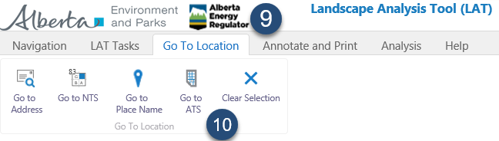
Figure 16 - Address Navigation

- Click on ‘Go To Location’ tab.
- Then search by any of these address references such as an ATS grid.

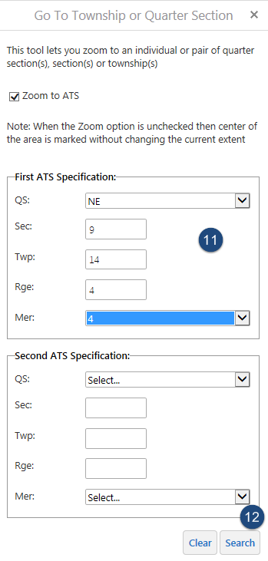
Figure 17 - Go to ATS Dialog Box

- Enter the ATS information.
- Click on the Search button. With the option Zoom to ATS checked, the map window would take you directly to the ATS grid upon clicking the search button. If you have an ATS reference which spans across two quarter sections, enter the second one under “Second ATS Specification” heading.

Close the Go to Township or Quarter Section panel by clicking the X button to return to the LAT Editor box.
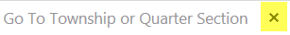
With the mouse pointer placed on the Map Window, left-click once to start drawing the polygon. For each vertex to be drafted, clicking on the left button of the mouse once plants the coordinate. Repeat the step until a closed-loop polygon is created.
On the final vertex, double-click on the left-mouse button to create a perfectly closed polygon.
From the LAT Tasks tab, click on LAT Report icon filling in your contact information and project description to have the LAT report delivered to the specified email address as explained in the link below:
- Figure 10 – LAT Report icon

At any point, to exit the edit session while plotting the polygon, tap on the Esc key on the keyboard to discard the drawing.

3 LAT User Interface
The LAT User Interface/Viewer includes the following:
- Toolbars.
- Side Pane / Menu pane.
- Map window.
- Magnification Controls.
- Toolbar icon shortcut.
- Coordinates widget.
- Scale Input Box.
- Quick Action button.
- Bookmarked Locations.
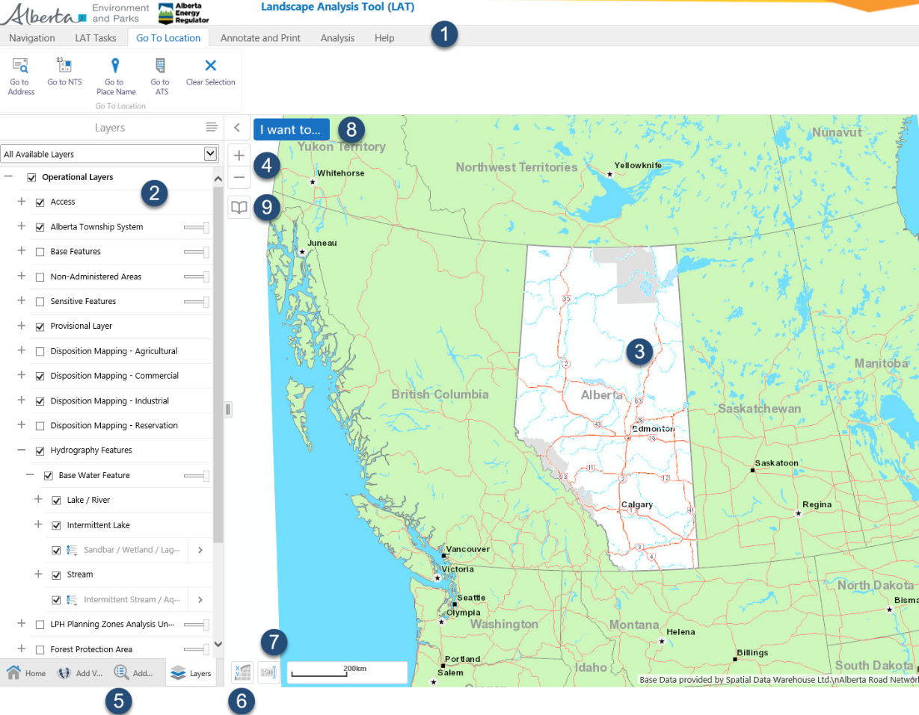
Figure 18 - LAT Viewer controls

3.1 LAT Toolbars
There are six toolbars on the LAT User Interface - Navigation, LAT Tasks, Go to Location, ‘Annotate and Print’, Analysis and Help. The toolbar has a collection of functions that are used most of the time when interacting with the interface.

3.1.1 Navigation
The Navigation pane of the toolbar is used frequently to access navigational functions when interacting with the map window.
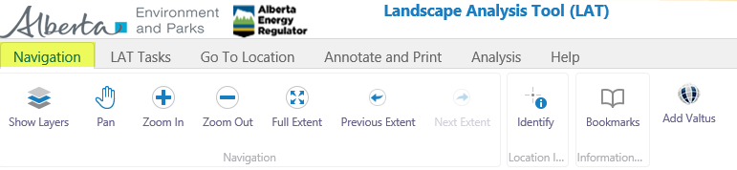
Figure 19 - "Navigation" Toolbar icons

- Show Layers - This is used to display the Proposed Activity, Operational Layers and Base maps layers.
- Pan - The pan tool allows you to pan around on the map viewer. To activate it, simply click on the icon, and then place the mouse cursor on the map window holding the left mouse button. Drag the mouse around at which point the cursor changes from an arrow into a quad arrow . While still holding the left mouse button, drag this cursor to the direction on the map window you wish to navigate to.
- Zoom In - The Zoom In tool allows you to zoom in on any part of the map. To zoom in, left click with the mouse button on the icon then place the cursor on the map window whilst still holding the left mouse button to draw a rectangle around the area to be magnified.
- Zoom Out - This is the reverse action performed by the Zoom In tool. To zoom out, click on the icon (left mouse button click), then place the cursor on the map window around the features to be zoomed out. Still holding the left mouse button, drag a rectangle around the features to be zoomed out.
- Full Extent - Once clicked, this allows you to zoom to the full map window’s extent. At full extent, the province of Alberta boundary is clearly visible.
- Previous Extent - This takes you to the previous view extent of the map window when clicked. It is similar to un-doing the map window to the scale you were at before.
- Next Extent - This allows you to zoom to the extent or scale you were at before you clicked on the previous extent icon. Its function is equivalent to a redo action, i.e., restoring to the zoom scale you were at before you clicked on previous extent.
- Identify - This allows you to identify features/layers on the map viewer. Simply click on the icon with the left mouse button and draw a rectangle around the borders on the map viewer to learn what features are available. A geo-marker is displayed on the location you clicked with the results displayed on the menu pane.
Two other icons are visible when you click on the identify tool; Enable buffering and Identifiable Layers.
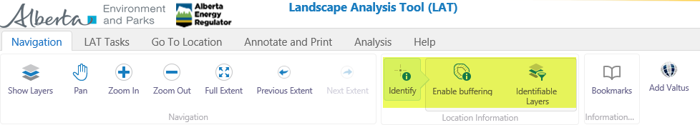
Figure 20 - Identify, Disable Buffering and Identifiable Layers icon on Tools toolbar

- Enable buffering - This tool allows you to select multiple features/layers by specifying a buffer distance. To activate this tool, click on it with your left mouse button. Once active you will see a check mark with the text changing from Enable buffering to Disable buffering.
A buffer windowpane is displayed on the side pane. Specify a buffer distance and default units. Once these values have been set, click on “Continue”. Now you are ready to draw a buffer distance on the map window. Hold the left mouse button, then place on the map window drawing a rectangle to depict the area where you would like to have its layers/features displayed. Once you are satisfied with the range, let go of the mouse button to see the different layers displayed represented by markers.
To display the information pertaining to the different markers, again click on the layers/features displayed on the side pane to view its details.
To disable buffering, simply click on the icon again. The text should at this point change from Disable buffering to Enable buffering.
- Identifiable Layers - This icon allows you to filter the layers to be identified when utilising the “Identify” or Enable buffering tool. To activate it, single click with the left mouse button, Identifiable layers are shown on the side pane. The layers are organised in a sequence so you might have to drill down to have some sub-layers either checked, i.e., to be identified or unchecked if layer is not to be identified. The Select All button when clicked selects all group layers and sub-layers while the Clear All button deselects all groups and sub-layers.

- Bookmarks - Bookmarks allow you to create reference points based on the current map extent you are viewing. To create a bookmark, left click on the icon with the mouse button, and then click on “Bookmark Current Extent”. Another dialog box pops open where you can specify a name for the bookmark you are about to create. Click OK to finish creating the bookmark.
After creating a bookmark, the icon becomes visible on the map viewer as shown under the “Bookmarked Locations” icon in Figure 18.
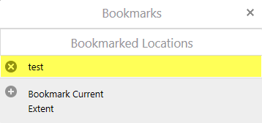
Figure 21 - Bookmarked Locations Box

Click on the Full Extent icon on the Navigations toolbar to view the province of Alberta boundary. Now go back to bookmarks icon on the same toolbar, left-click with the mouse button to launch the tool and then left click on the bookmark you created earlier to be taken to its view extent. For instance, according to Figure 21, I click on “test”. Instantly, the map viewer zooms to the location where I had the “test” bookmark added.
- Add Valtus – This feature icon allows Valtus Views Imagery to be added to the LAT site. You need a VIEWS Userid and Password to access the imagery in accordance with the licence agreement. If you do not have an account, please go to the link below to request for access.

- Valtus
Once Valtus authorization is secured, from the LAT Interface, click on Valtus icon under the Navigation toolbar.
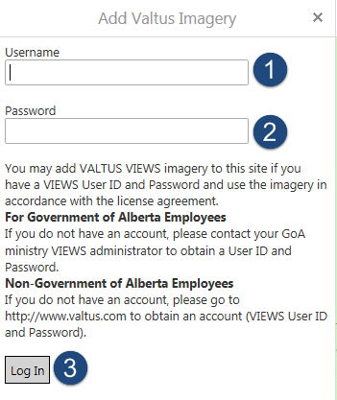
Figure 22 - Logging into Valtus Imagery

- Enter your Valtus User ID.
- Enter your password.
- Click Login.
The next pane includes some added layers on display. Check the layer’s box to display the imagery on the map viewer.
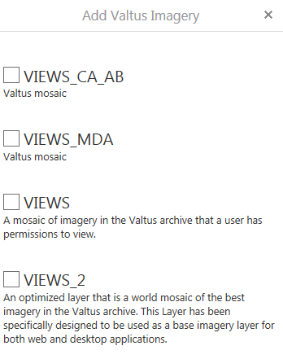
Figure 23 - Adding Valtus Imagery

3.1.2 LAT Tasks
The LAT Tasks allows you to generate a LAT report by either uploading a shapefile according to the LAT specification or using the in-built LAT Editor tool.

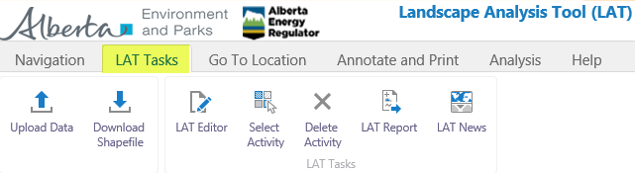
Figure 24 - “LAT Tasks” Toolbar icons

- Upload Data - This allows you to upload a shapefile containing the proposed activity boundary for which a LAT report is to be generated. Kindly refer to the following link below on how to use this icon:

- Figure 4 – Adding a Shapefile

- Download Shapefile – To download a shape that was drafted using the LAT Editor tool or to simply create a duplicate shapefile from the one that was imported into the LAT map viewer, click on Download Shapefile icon under the LAT Tasks toolbar. The LAT Download action is displayed on the side pane as seen below.
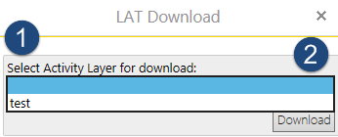
- Click on the drop down arrow to select the proposed activity layer, for which you want to download the shapefile.

- Click on the Download button to have the layer downloaded as a shapefile. A confirmation dialog box is shown afterwards. To proceed with downloading the shapefile, click the OK button. To retract the action, click the Cancel button. A window pops up next prompting you to save the file to your directory.

LAT Editor - The LAT Editor allows you to create a proposed activity layer and have its point, line or polygon boundary drafted based on the location of the proposed site. Thereafter, you can generate its corresponding LAT report. Refer to the following on how to use this icon:.

Step B – Adding Proposed Activities into LAT Using the LAT Editor Tool

- Select Activity - This icon allows you to select a sketched activity polygon on the map window. The activity’s geometry (point, line or polygon) boundary must be displayed on the map viewer before utilizing this tool. To use it, click on the icon with the left mouse button, then left-click on the geometry to have it selected. At this point, the geometry has its vertices displayed as shown below.
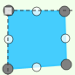
Once it is highlighted, you can perform different actions like moving it to another location on the map window, editing its size or deleting the geometry.
- Moving the Proposed Activity - To re-position the proposed activity, click on “Select Activity” which is accessible under LAT Tasks > Select Activity. Click the icon (Select Activity) with a single left-click of the mouse button, then left-click once on the object on the map viewer. Once selected, there are vertices around its edges in white. To move, hold the left mouse button and then drag to your desired location. Release the mouse button once you are satisfied with its new location.

- Resizing the Proposed Activity - To resize the geometry while selected, click (left mouse button) on any of the white vertices as illustrated in the diagram below (purple nodes). Once the vertex is active, the mouse cursor changes from a single arrow to a vertical bi-directional one

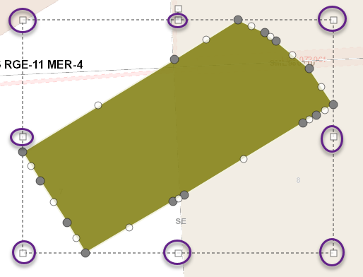
Figure 25 - Resizing a Proposed Activity

Holding the white vertex with the left-mouse button, drag it outwards to increase its size or inwards to reduce it. The shape’s proportion is maintained such that it is represented at a larger scale when increased in size or at a lower scale when reduced.
- Rotating the Proposed Activity - To rotate the shape after being selected, left-click on the vertex highlighted in yellow from Figure 25 above. Holding the left-mouse button, still planted on the vertex, drag towards the right to rotate it in a clockwise direction or towards the left to rotate it in an anticlockwise direction.

- Deselecting the Proposed Activity - To deselect the proposed layer, simply click (left mouse button) anywhere on the map viewer outside the boundary of the selected geometry, i.e., defined by the white vertices. Once deselected, you should not see the white vertices anymore.

- Delete Activity - To delete the geometry after being selected, click on “Delete Activity” icon accessible from LAT Tasks > Delete Activity. A Delete Confirmation window pops up next as shown in the figure below. Click OK to confirm deletion of the shape or Cancel to abort the deletion task

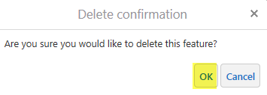
Figure 26 - Delete Confirmation window for a Proposed Activity

- LAT Report - This icon when clicked allows you to enter project description and contact information including an email address where the LAT report will be delivered to. For more hints on using this icon, refer to:

- Figure 11- LAT Report Contact/Project Information Dialog Box1

- LAT News – This icon allows you to see recent LAT News publications.

3.1.3 Go To Location
This toolbar contains several icons used for panning to the exact location of the proposed activity especially when drafting the shapefile’s geometry using the “LAT Editor tool”. Other uses also include unearthing existing layers, which exist at a geo-location.
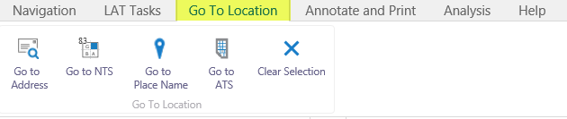
Figure 27 - – Go to Location toolbar

- Go to Address – The Go to Address tool enables you to zoom to any location with a permanent address in the province of Alberta. Addresses searched within the tool that lay outside the province of Alberta returns an error message saying, “The item is outside of the current extent”.

- To query an address, type the address into the search field.
- Click the search button to have the map viewer zoom to this location.
- A couple of address suggestions are retrieved based on the search that was made. Scrolling through this list, identify the closest match to the address you want to zoom to by tapping the left mouse button. Instantly, the map viewer zooms to the location provided the checkbox “Zoom to” is activated
- Address is returned with a marker symbol.

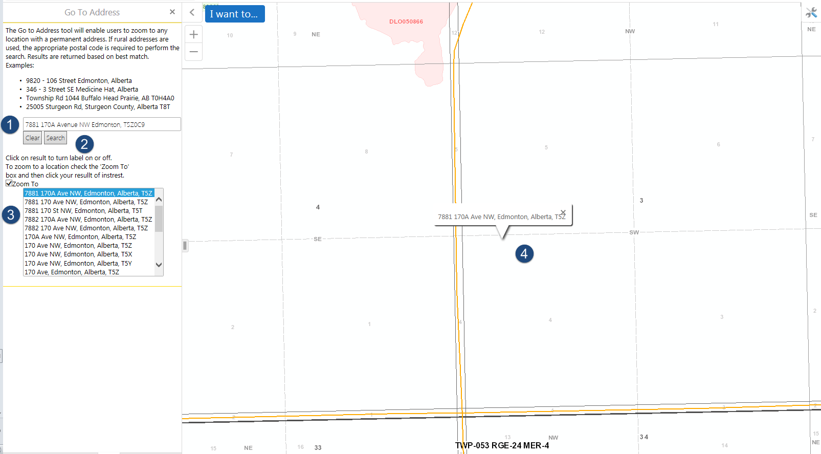
Figure 28 - Go To Address Search Field

- Go to NTS – NTS is an acronym for The National Topographic System of Canada, which is a mapping reference grid defined by National Resources Canada that is based on degrees of latitude and longitude. This tool allows you to search for polygon grids based on the scale of 1:50000 NTS extents within the province of Alberta. The format for each polygon’s grid extent is a two-digit number, a single letter and two additional numbers.
To run a search, type the NTS reference within the search field and then click on the Search button to be zoomed to its location.
- Go to Place Name – The “Go to Place Name” search allows you to locate any formally named feature as recognized in the Geographic Names System database. To execute this tool, simply key in the place name in the search field and once again clicking on the Search button displays a pane underneath with place name suggestion in the database that is closest in match to the one typed.
To zoom to the place name of interest, left-click on it as seen from the address list section. Ensure the checkbox “Zoom to” is turned on.
- Go to ATS – This tool lets you zoom to an individual pair of Quarter Section(s) [QS], Section(s) [Sec], Township(s) [Twp], Range(s) [Rge] and Meridian(s) [Mer] within the province of Alberta.
The valid input values are:
- QS (NE, NW, SE and SW)
- Sec (1-36)
- Twp (1-126)
- Rge (1-30) and
- Mer 4-6
To zoom to any ATS section, fill in the field values for First ATS Specification and an optional Second ATS Specification especially where the layer’s boundary spans across the First and Second ATS specification values. Click the Search button to be zoomed to this ATS location.
Likely error messages encountered are when ATS field values keyed in falls outside the range of accepted values or when the ATS values entered lies outside the province of Alberta. The error message displayed in these circumstances is shown below.

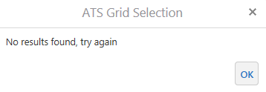
- Clear Selection – Clear Selection icon when clicked deletes all drawings (shapes) that have been added to the map viewer. A confirmation message displays asking if you want to delete all current drawings on the map viewer. Click on the OK button to proceed.

3.1.4 Annotate and Print
The Annotate and Print toolbar contains a library of functions that allows you to connect to external mapping services like GeoDiscover Alberta and to perform basic geospatial representation like drawing of points, polygons, inserting text annotations etc.

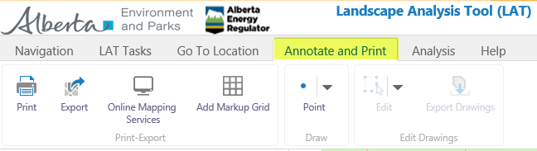
Figure 29 - “Annotate and Print” Toolbar icons

- Print – The Print icon when clicked allows you to print a defined map scale based on the extents on the map viewer. Select the print layout from the drop down. The fields: Output Format and Resolution have default values while the Map Scale field can be specified. Alternatively, you may add a Map Title and Comments to the printed map.
The option “Lock print preview with map” should be unchecked if you wish to move proposed activity polygons to fall within the print area denoted by the brown coloured boundary otherwise the polygons/geometry on the map viewer is locked in position and may not fall within the boundary of your print section. Once all these field values have been entered, click the Print button to execute the print function. You should see a confirmation window afterwards saying, “Your file is ready.
Click the Open file button to open the printed map.
- Export – The Export icon enables you to export the map preview from the viewer into several image formats, which includes PNG, JPEG, BMP, TIFF, GeoTIFF and PDF.
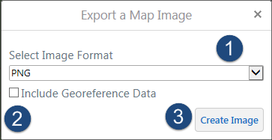
Figure 30 - Exporting a Map Image

- Select the output file format.
- Checking this box includes a projection file to the ‘image format’ file selected which is available to be downloaded as a compressed zip folder. Unchecking it produces just the image file format. For illustrative purposes, this option is checked off.
- Click on Create Image to have the file exported.
Another dialog box displays with the option to click on a button that says “View Image”. Click this button to have your map image displayed. The next window to pop up has several options for viewing the file; whether to open it directly or to save it to a directory on your computer. Open the image ending in the file extension you selected in Step 1.
If the checkbox in Step 2 isn’t checked off, running step 3 opens the image in a new browser tab. To save it, right click on the image in the browser and choose Save Picture as…proceed to saving this in a file directory on your computer.
- Online Mapping Service – This icon when clicked allows you to connect to GeoDiscover Alberta, which is the province geospatial data authority that contains a catalogue of datasets and its metadata. It is the focal point for easily integrated and usable geospatial data and services including metadata searches.

- GeoDiscover Alberta

- Add Grid Markup – The Add Grid Markup tool allows grid lines to be added to the map viewer. Pan to the area of interest on the map viewer, then click on this icon specifying a grid line distance in km followed by the OK button. Immediately, a grid line with the specified parameter is displayed on the viewer. To remove the grid line, click on the Remove button.
- Point – The point icon enables you to draw various shapes into the LAT map viewer. To draw a shape.

- Click on the Annotate and Print toolbar.
- Click on the Points icon drop down arrow.
- Then hover to the shape you would like to draw, click on it. Thereafter proceed by drawing the shape on the map viewer.
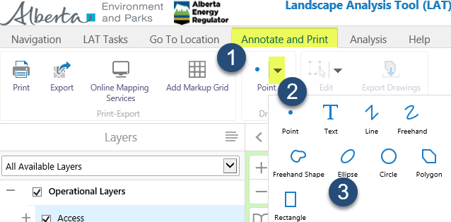
Figure 31 - Drawing Shapes under the Tasks>Point Icon

- To represent a point on the LAT map viewer – Following from the previous step, click on the Point shape from the drop down. Proceed by a single click of the left mouse button on the map viewer to insert the point. A blue dot should appear immediately.

- To insert a Text – Click on the Text symbol from Figure 31, then single-click with the left mouse button on the map viewer where you would like the text inserted. You should see a confirmation window pop up verifying if you would like to add the text at the location on the map.
Enter the text in the field then click “OK”. The text should be inserted at the location now.
- To insert a Line – Click on the Line symbol from Figure 31, then single-click on the left mouse button on the map viewer to start drafting the line. For each vertex, click the mouse button once, once finished double-click the left mouse button to finish the line sketch. To delete the line at any instance, tap the Esc button on your keyboard.
- Freehand – To use the freehand tool, click on the drop down from the figure above selecting the freehand icon, a tip is displayed at the bottom of the viewer saying you should hold the (left) mouse button or your fingertip down and then draw a freehand line on the viewer. Release the mouse button to finish the sketch.

- Freehand Shape – Similar to the Freehand Line, click on this icon and then holding the left mouse button draw the shape on the viewer. Release the mouse button to finish the sketch.

- Ellipse – To draw an ellipse, click on the icon followed by holding the left mouse button dragging it on the map viewer to draft the shape. To finish the sketch, release the mouse button.

- Circle – To draw a circle, click on the icon then holding the left mouse button proceed to the map viewer dragging it on the location where the circle is to be inserted. Release the mouse button to finish drafting the shape.

- Polygon – To draft a polygon, click on the icon, then with a single left click of the mouse button, tap to start drafting the vertex. Proceed by tapping another location to insert the next vertex. To enclose the polygon shape, double-click the mouse button at the final vertex, which is also the start vertex to complete the drawing.

- Rectangle – To draw a rectangle, click on the icon and then holding the left mouse button; drag the shape on a location on the map viewer. Release the mouse button to complete the sketch.
Some additional icons are displayed based on which of the shapes listed above are selected. They are:
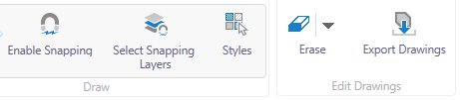
- Enable Snapping - Once this tool is checked by clicking on it, it enables the functionality to sketch the shape selected from the Point icon dropdown to a higher degree of accuracy by snapping the vertices to features on the map viewer. A white dot can be seen once this tool is enabled and when you move the mouse cursor to a feature on the map viewer. This is an indication to start the sketch as the first vertex is snapped to the feature. To disable, simply click the icon again.

- Select Snapping Layers – This icon allows you to define which layers listed in the side pane are to be snapped. To use this icon, simply click on it and then select the applicable layers from the list. You can select the layers either manually by clicking on the checkbox or by clicking the “Select All” button to have all layers selected to be snappable. Layers with a ‘+’ symbol denote it is a grouped layer and there are sub-layers present. Simply click on the + symbol to expand it until a layer becomes visible with a checkbox. To remove layer(s), which have been checked earlier, either drill down to the individual layer manually and uncheck the box or to uncheck all the layers, click on the Clear All button.
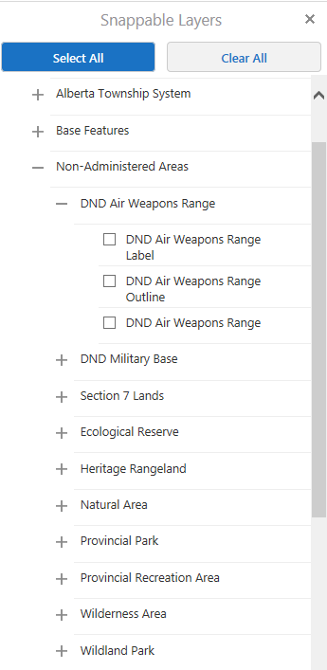
Figure 32 - Snappable Layers

- Styles – Styles icon contain predefined styling options for the shape selected from the drop down. Click the styles icon, then the desired styling option from the popped up window before sketching the shape. Notice that the shapes sketched on the map viewer adopt the styling option selected.

- Erase – The Erase icon drop down has three sub-icons, which are Edit, Erase and Clear.

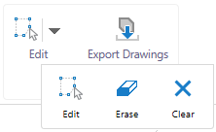
Figure 33 - Edit Icon drop down

- Edit – Once clicked, this allows you to edit an existing drawing on the map viewer. This tool only works on all shape symbols including points, text, lines and polygons. To edit the symbol, click on the Edit icon, then tap the exisiting drawing or symbol on the map viewer. You can thereafter perform additional functions like editing the vertices, rotating the symbol or moving it to a new location.
For hints on how to edit the symbols, kindly refer to: Figure 23 – Adding Vaultus Imagery
- 3.1.2 - LAT Tasks

- Erase – The erase icon as the name indicates allows you to erase any symbol/shape which have been drafted on the map viewer. To utilise the tool, click on the erase icon and then proceed by tapping on a shape that was sketched on the map viewer. You should notice the shape is completely erased.

- Clear – The clear icon when clicked displays a confirmation window informing you all current drawings on the map viewer are permanently erased. Click OK to proceed with this action.

- Export Drawings – The Export Drawing icon when activated displays a confirmation window notifying you the “.shp” file (shapefile) is about to be downloaded. Click OK to have all the objects drawn on the map viewer exported in a shapefile format. Proceed by opening or saving the zip file. You will need access to a GIS software, e.g., ESRI ArcMap, QGIS etc. to open a shapefile.

3.1.5 Analysis
The Analysis toolbar contains a library of functions that allows you to specify shapes to be drawn based on surface measurements: area and distance. You can also plot coordinates defined in a coordinate system.
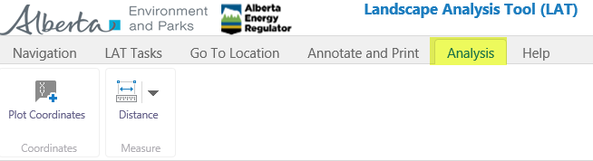
Figure 34 - Analysis Toolbar icons

- Plot Coordinates – This icon allows you to plot XY coordinates (Eastings and Northings) in a defined coordinate system. Click on the icon, typing in the Easting and Northing represented as X and Y. Select the coordinate system where the coordinates are plotted in from the drop down arrow on the Coordinate System field.
Click the Add button to add the coordinates to the map viewer.

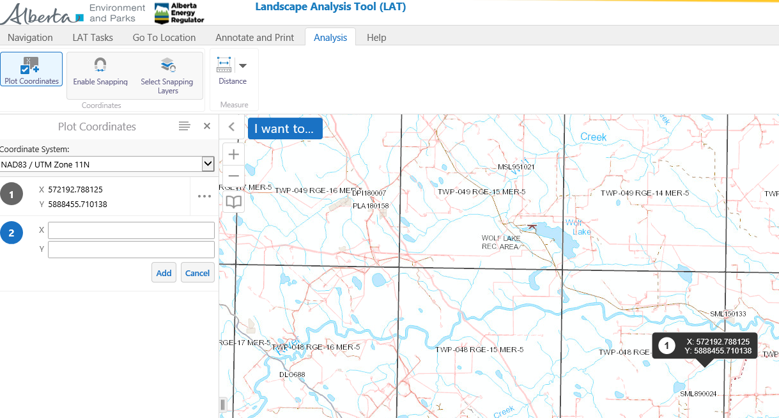
Figure 35 - Plotting a Coordinate

Similarly, you can plot a new coordinate on the map viewer by placing the mouse pointer to the location on the map viewer where the coordinate is to be inserted. Right click on the mouse button and then left click once on the option that says, “Plot a Coordinate”. The second coordinate is plotted with a marker icon denoted by ‘2’ in the screenshot above.
To delete any of the coordinates or to delete all of them, refer to Erase and Clear icons at
- Figure 33- Edit Icon Drop Down3
They can also be deleted by clicking on the ellipsis beside the coordinate on the side pane as shown below. Three options are available, which are Hide Coordinate, Edit its location and Delete.

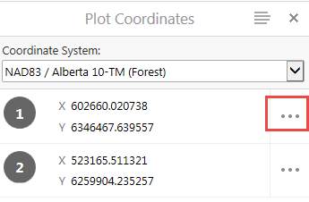
Figure 36 - Deleting a Plotted Coordinate

- Distance – The Distance icon is used to measure the distance between two features on the map viewer. To use the tool, click on the Distance icon as shown from Figure 35. The next available option is to set the units for distance to be calculated from the drop down arrow. Once all these parameters have been set, click on the first point on the map viewer and then hover the mouse to the next feature. You should immediately notice a line extension. Double click on the second feature to calculate the distance between them. Distance calculated should now be visible with the line separating those features highlighted in blue.

- Area – The Area icon as the name implies is used to calculate the area across features or land as represented on the map viewer. By default, areas are only calculated on Polygon shapes. Following from the Distance icon, click on the drop down arrow to switch to the Area icon. Set the unit for which area is to be calculated – we have used meters here. To start calculating the area across a region on the map viewer, move the mouse to the start point single clicking on the left button. To continue drafting, extend the mouse to the next point, again with a single-click at the location to plot the next vertex. Proceed with these steps until a polygon enclosure is created. Double-click to complete the polygon sketch depicting the area of the region.

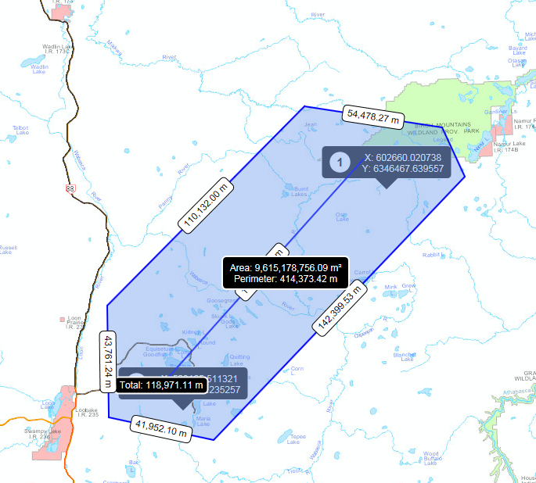
Figure 37 - Calculating the Area of a Polygon

All the line segments characterizing the polygon boundaries as seen from Figure 37 all have their lengths calculated in metres. The centre of the polygon also displays the Area in m2 and its perimeter.

3.1.6 Help
The Help toolbar contains links to the EDS/PCS/LAT Technical Helpdesk contact information as well as links to the LAT User Guide and LAT Activity Codes lookup table.
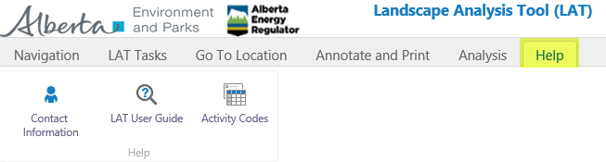
Figure 38 - Help Toolbar

3.2 Side Pane
The Side Pane is a vertical display to the left of the map viewer, as seen in:
- Figure 18 – LAT View Controls8
The content displayed here is dependent on what toolbar icon shortcut is active at the time. For instance, the layers list is shown because the Layers icon shortcut is active from the Figure. Switching the Active toolbar icon shortcut to Home (bottom left of the map window) by clicking on it changes the content in the Side Pane to the LAT home page / welcome message.
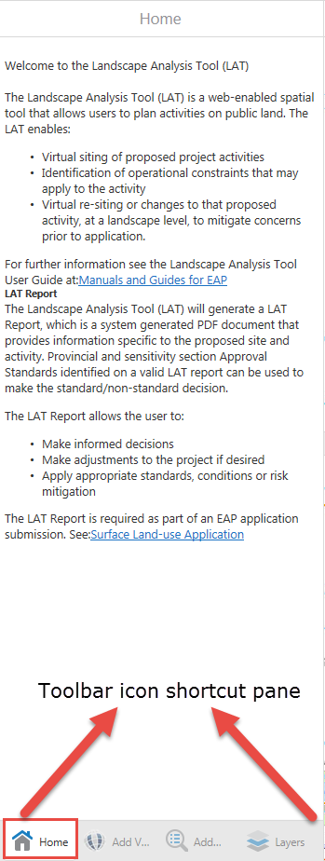
Figure 39 - Active icons on Side Pane

3.3 Map Window
The Map window is the graphical layout where all the base maps, operational layers and proposed activity layers are displayed. It is the workspace where you can see a graphical display of layer interactions and apply several toolbar icons functions within the LAT program.

3.4 Magnification Controls
The Magnification Controls is used to zoom in and out of the map window as displayed from Figure 18 – LAT Viewer controls. To zoom in, click on the (+) control. To zoom out, click on the (–) control.

3.5 Toolbar icon Shortcut
The toolbar shortcut as seen from Figure 18 – LAT Viewer controls is a collection of LAT icons created as a shortcut. Once the icon is closed from the side pane, the shortcut disappears from the toolbar icon shortcut pane. To have it displayed again, simply locate the icon and click on it from the toolbar icons.

3.6 Coordinates Widget
The co-ordinates widget shown in Figure 18 – LAT Viewer controls is used to define a coordinate system used to project features on the map window. Their respective coordinates are shown alongside one another. The coordinate value changes as you pan features on the map window.

3.7 Scale Input Box
The Scale Input Box as revealed on Figure 18 – LAT Viewer controls shows the scale of elements in proportion to the map viewer/window. The default unit is in kilometres/metres. As you zoom in or out on the map window, the value on the scale input box changes.

3.8 Quick Action button
The Quick Action button referred to on Figure 18 – LAT Viewer controls has three options when clicked which are:
- Change visible map layers – This allows you to alter the visibility of map layers, perform layer actions and view the legend.

- Return to initial map extent – This icon when clicked takes you to the initial map position and zoom level.

- Bookmark current map extent – This icon when clicked adds the current map extent to the list of bookmarks, so you can return to it later.

3.9 Bookmarked Locations
The Bookmarked Locations icon is a shortcut to the Bookmarks functions where you can access previously saved bookmarks or create a new bookmark based on the current map extent. It is worth noting the icon is only available if you have created a bookmark extent on the map viewer.
An example of this can be seen at
- Figure 18 – LAT Viewer Controls8

4 Troubleshooting LAT Report Error Messages
Some error messages may be encountered when running a LAT report as some restrictions do apply based on areas of sensitivity that should never be intersected. Below are some of the most common errors you may notice.

4.1 Non-Admin Areas
A Proposed Activity layer should never be located within a Non-Administered Area. A sample LAT report is shown below where this error message was displayed. This implies you are prohibited from having a proposed activity in a Non-Admin area and to resolve this conflict, you need to establish your activity elsewhere.
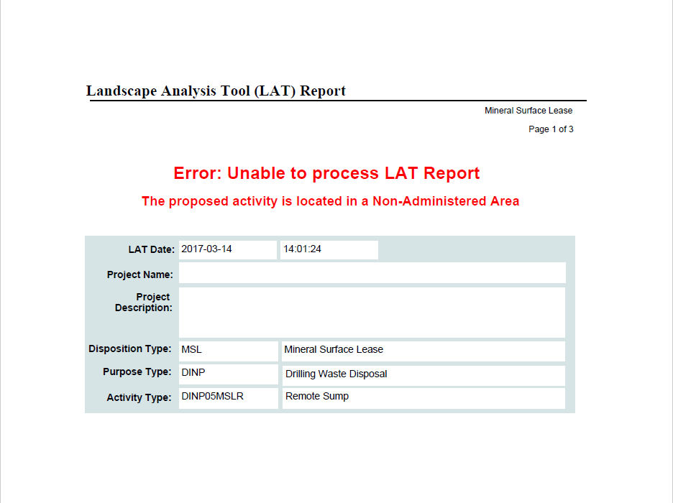
Figure 40 - LAT Report Error Screenshot – Non Admin Areas

4.2 Invalid Activity Code
Invalid Activity Code implies that the shapefile attribute field ACT_TYPE contained in the shapefile that was imported to the LAT Map window contains an invalid activity code. To remedy this error message, refer to
- Appendix A - LAT Shapefile Specification for Proposed Activities
Make sure that an eligible activity code was used for the ACT_TYPE field in the shapefile’s attribute data. For a list of the eligible codes, you can refer to the LAT Activity Code table document found at
- Electronic Disposition System
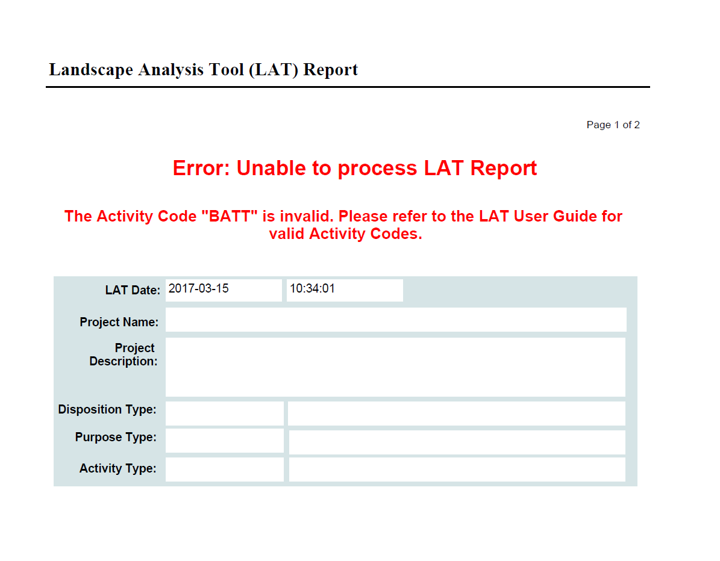
Figure 41 - LAT Report Error Screenshot – Invalid Activity Code

4.3 Out of Province
LAT reports are not to be generated for proposed activity layer where the disposition boundary lies outside the province of Alberta. The proponent should have a shapefile created for the disposition’s boundary that lies completely within the province of Alberta.
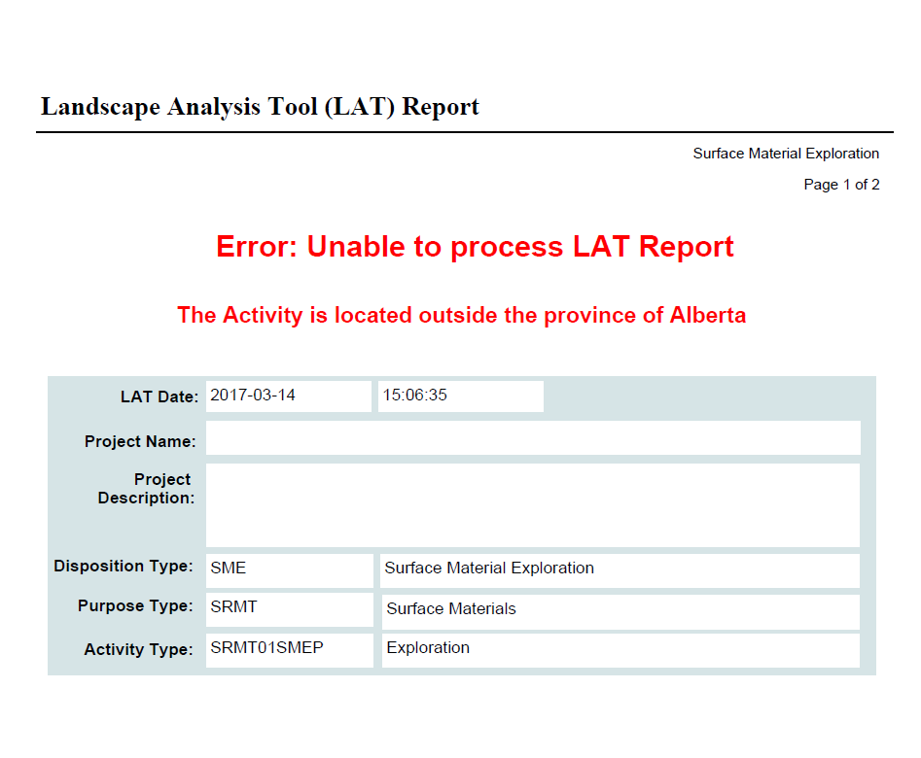
Figure 42 - LAT Report Error Screenshot – Out of Province

4.4 Peat Extraction not allowed
Proposed project activity layers for Peat extractions must fall completely within the Peat Availability Area layer located under the Sensitive Features group layer on the layer list section of the LAT Viewer. An error message will be displayed for peat activities where the disposition boundaries lie partially or completely outside the Peat Availability Area layer.

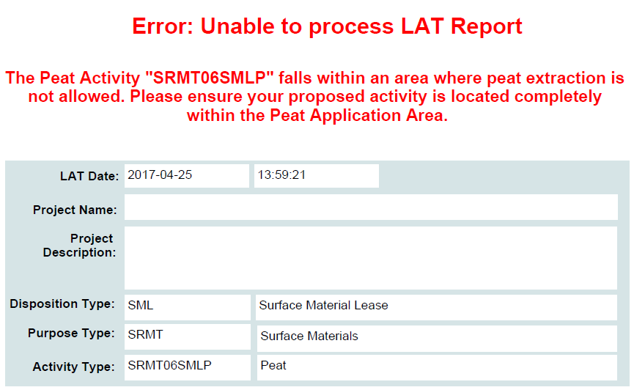
Figure 43 - LAT Report Error Screenshot – Peat Extraction not allowed

To resolve this, the proposed project activity boundary will have to be re-sited to fall completely within Peat Availability Area layer.

Appendix A - LAT Shapefile Specification for Proposed Activities

Introduction:
The shapefile format is the native format of Environmental Systems Research Institute’s (ESRI) ArcView product. Shape records store both geometry and attributes for features. Shapefile records on a vast occasion consists of six files, however only four are required for the LAT “Upload Shapefile” functionality. The files required are:
- Shape records (geometry) are stored in the .shp file. This is the main file.
- Attribute records are stored in the .dbf file. This is a dBase file.

- A projection .prj file that contains the map projection and datum information.

- An index (.shx) file.

These extensions are added to the base name of the file. e.g., test.shp, test.dbf. test.prj, test.shx etc.

File naming:
Please note the following
- For LAT, the shapefile can only contain polygon shape features

There are no standards with respect to the naming convention for the base name (prefix), as long as it is supported by the ESRI shapefile format. The shape records attribute records and projection file must all have the same base name. For example gravel.shp:
Gravel – This is the base name while .shp – is the extension, so all four files to be uploaded to LAT are named as (Gravel.shp, Gravel.dbf, Gravel.prj and Gravel.shx) with other extension files optional.

Map Projection and Datum:
All shapefiles must be in 10TM_AEP_FOREST projection. The following .prj file parameters are required.
PROJCS["NAD_1983_10TM_AEP_Forest",GEOGCS["GCS_North_American_1983",DATUM["D_North_American_1983",SPHEROID["GRS_1980",6378137.0,298.257222101]],PRIMEM["Greenwich",0.0],UNIT["Degree",0.0174532925199433]],PROJECTION["Transverse_Mercator"],PARAMETER["False_Easting",500000.0],PARAMETER["False_Northing",0.0],PARAMETER["Central_Meridian",115.0],PARAMETER["Scale_Factor",0.9992],PARAMETER["Latitude_Of_Origin",0.0],UNIT["Meter",1.0]]

Geo-referencing:
There are no standards with respect to geo-referencing; however, for optimal results users should consider geo-referencing their data to the DIDS (Digital Integrated Dispositions) layer, or to the Base Features ATS Version 4.3.1
Shapefile Size Limitations:
- The combined size of the four Shapefile files must not exceed 20480 KB.

Proposed Activity Size Limitations:
To optimize system performance, the following size limitations have been applied to Proposed Activities:
- Using the online LAT Editor tool, the maximum area that can be drawn on the map viewer is 2,000 hectares (20,000,000 square metres).

- Using the online LAT Editor tool, the maximum number of polygons, polylines or points that can be drawn in a viewer is 10.
NOTE: These limits may be adjusted from time to time.

Shapefile Attributes and Attribute Values:
The following table contains a description of the required attributes and attributes values represented as fields within the shape .dbf file.
Field Name | Type
ACT_TYPE | TEXT(10)

Table 2 - Shapefile Attributes and Attribute Values

The ACT_TYPE code field name and value are both mandatory data that is required for a successful LAT report generation. This information is used to select the appropriate approval standards and operating conditions associated with the proposed project location. The disposition, purpose type and activity type are displayed on the LAT report.
The Activity Code Table can be downloaded by clicking on the ‘Activity Codes’ icon in the ‘Help’ ribbon of the LAT interface. The pdf document LAT Activity Code Table seen on the web page should be downloaded to retrieve the corresponding ACT_TYPE code for the proposed project.
The ACT_TYPE code to insert in the shapefile’s attribute table is retrieved from the LAT Activity Code Table PDF sheet, under the field name “Activity Code”.
Select the applicable code referenced by the disposition, purpose and activity description you would like a LAT report generated for your proposed project location.

