Modular Classroom Prep Sheet

Instructions: In preparation for the receipt of your new modular classrooms, please provide your regional representative with the following information for each school site that is to receive new modular classrooms:
Core Information:
Name of School Board: | Select a School Board.
Name of School Board Contact: | Click here to enter text.
School Board Contact Phone No, Email Address: | Click here to enter text.
Name of Receiving School: | Click here to enter text.
School Address: | Click here to enter text.
Project Type: | MCP: ☐ | AI Managed: ☐ |  | Grant Funded: ☐ |  | Self-Funded: ☐
Attaching to Existing Modular or Core School: | Stand Alone: ☐ |  | Existing Modular: ☐ |  | Core School: ☐
Date Units Required for Pick up: | Click here to enter a date.
Procurement Strategy: | Tender: ☐ |  |  | Own Forces: ☐

Important Notice: Prep Sheets must be submitted with a “Required by Date”. Storage fees accumulate at a rate of $100 per business day per unit commencing 60 days after the “Required by Date” as indicated above and on the Purchase Order. If Own Forces has been selected, please see the Own Forces Responsibility Checklist below (See Page 4).

Please use the chart below to identify the number of modular classrooms of each type that are required.
(See Page 4 for unit type reference)

Unit Type: | Type A |  |  |  |  |  |  |  |  |  |  |  | Type B
 | A1 | A2 | A3 | A4 | A5 | A6 | A7 | A8 | A9 | A10 | A11 | A12 | B
Standard Duty | No. | No. | No. | No. | No. | No. | No. | No. | No. | No. | No. | No. | No.
Intermediate Duty | No. | No. | No. | No. | No. | No. | No. | No. | No. | No. | No. | No. | No.
Heavy Duty | No. | No. | No. | No. | No. | No. | No. | No. | No. | No. | No. | No. | No.
Washroom | No. | No. | No. | No. | No. | No. | No. | No. | No. | No. | No. | No. | No.
Vestibule | No.

Modular Classroom Prep Sheet

Options: | Select Options | Options: | Select Options
L-shape Millwork & Sink (See Figure 1) | ☐ | Air Condensing Unit | ☐
L-shape Millwork without Sink | ☐ | Controls | ☐
Millwork by Windows (See Figure 2) | ☐ | Sprinklers | ☐
Coat Rack Millwork (See Figure 3) | ☐ | Lockers (See Figure 5) | ☐
Boot Rack (See Figure 4) | ☐

Site Plan:
A fully dimensioned site plan showing the location, orientation of the modular classrooms, and site access points for both the donor and receiving school(s). The site plan should clearly indicate the type of modular classroom that will be present (A-Unit, and/or B-Unit), along with their respective orientation.

Important Notice:
For all modular classrooms approved under the Modular Classroom Program (MCP), if the Modular Classroom Prep Sheet has not been received prior to April 30, 2026, your unit(s) are not guaranteed to be on site for the 2026/2027 School Year.

Please email a completed checklist along with the site plan to Alberta Infrastructure:
Modular Classroom Program – Infras.MCP@gov.ab.ca

Cost Estimate: Only required to be completed for orders as part of The Modular Classroom Program (MCP). Please double click to enter information into the below excel table (See Page 3).
- Note: If your tender results exceed Alberta Education’s (AE) project budget, your consultant fees and project expenses will be calculated based on the max AE budget for your project and not your total building construction cost.
Additional Considerations:
To best capture the estimated costs associated with site preparation, the following section has been added to answer common questions.

Manufacturing Clarifications:
- For units with the millwork sink option, there is no sump pump. System is gravity drained.
- Sprinkler line verification and fire alarm verification are not completed by the manufacturer.
- Utility hook-ups are not completed by the manufacturer.
- Air Condenser is shipped loose and needs to be installed at site by General Contractor.
- Smartboard and PA system wiring is not included.
- Fire/Smoke Dampers are included in modular classroom.
- General Contractor takes responsibility of modular classrooms during transportation. Any window damage or wall cracks that occur during transportation are the responsibility of the General Contractor.
- The modular classroom has a one-year warranty that starts when the unit is picked up from the manufacturer.

Modular Classroom Program Clarifications:
- Unless identified on Form 9 – Modular Classroom Program Request and subsequently approved by Alberta Education, additional school modifications or improvements will not be supported by the Modular Classroom Program. (Ex. Parking Stalls, Additional Washrooms, Firewalls, etc.).
- Project Management fees are not supported.
- Costs incurred prior to approval from the Modular Classroom Program are not supported.

Modular Classroom Prep Sheet

Own Forces Responsibility Checklist: Only to be completed and checked off by School Jurisdictions that elect to utilize The Own Forces Procurement Strategy (as per the School Capital Manual).

School Jurisdictions utilizing the Own Forces Procurement Strategy are responsible to:
☐ | - Acknowledge the risks and responsibilities to the school jurisdiction when acting as the prime contractor.  - Obtain and submit to Infrastructure confirmation of site and liability insurance for the project.  - Provide confirmation that appropriate permits have been or will be obtained; and  - Provide rationale to Infrastructure for the use of the Own Forces delivery method submitted with the completed prep sheet.

Classroom Unit Configuration:

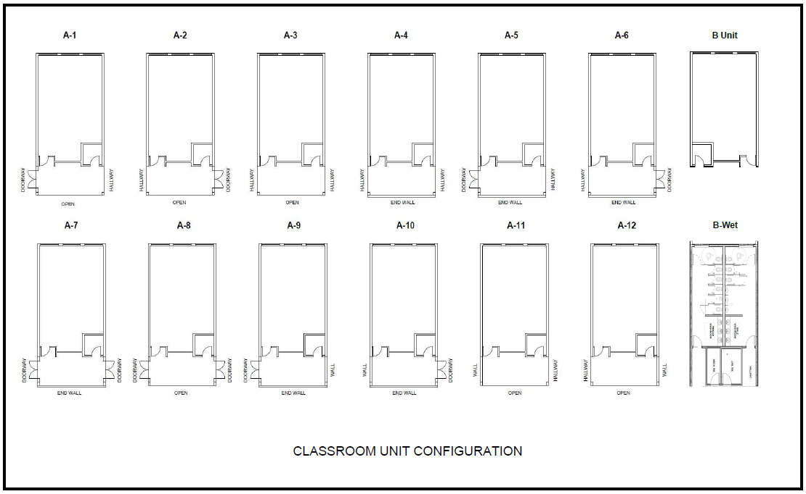
Modular Classroom Prep Sheet Options
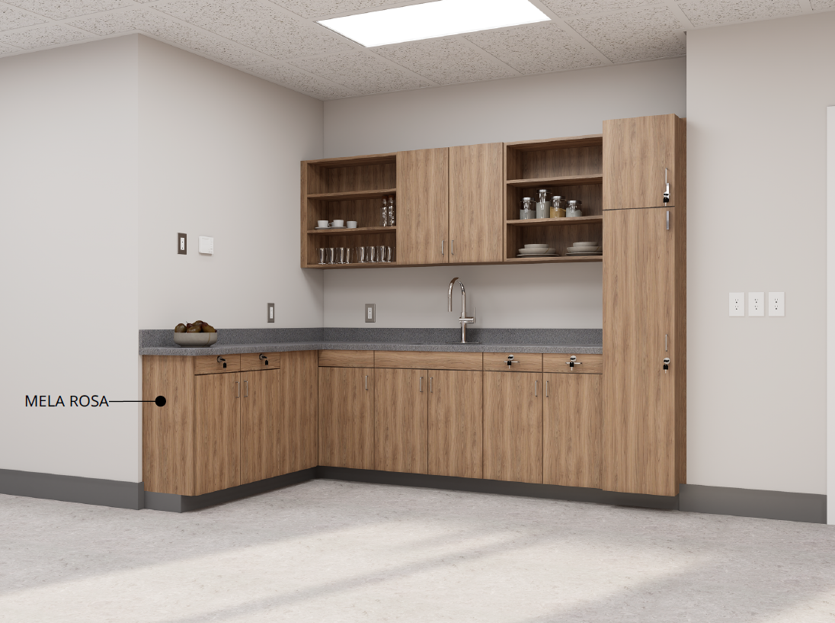
Figure 1: Millwork and Sink
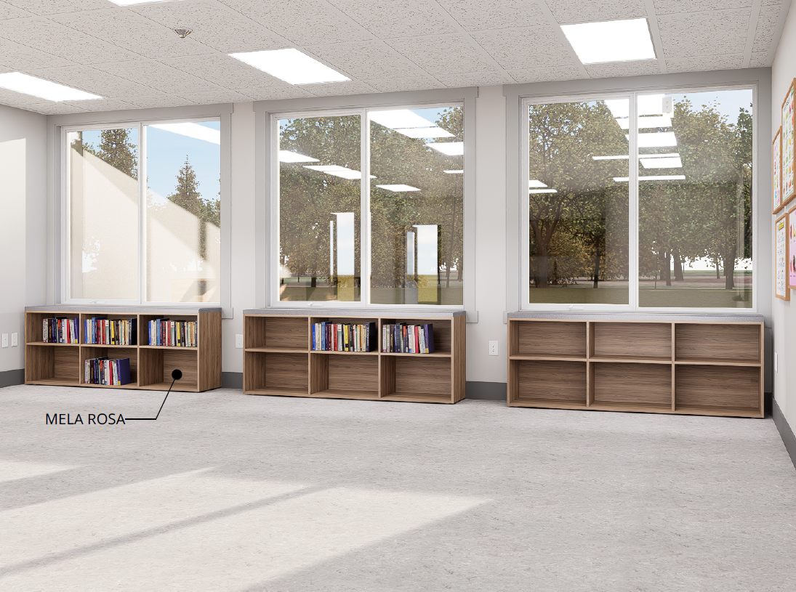
Figure 2: Millwork by the Windows

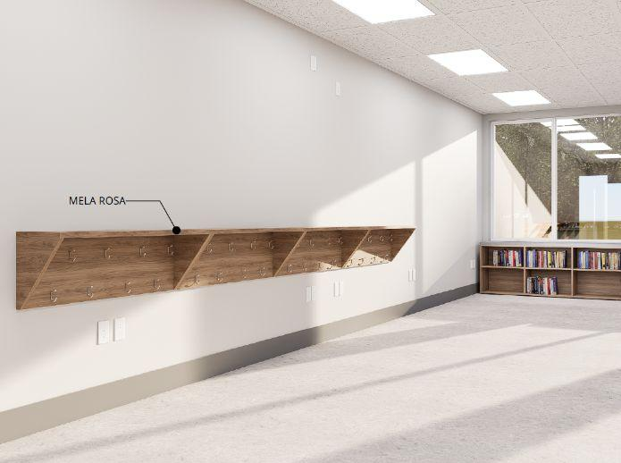
Figure 3: Coat Rack Millwork

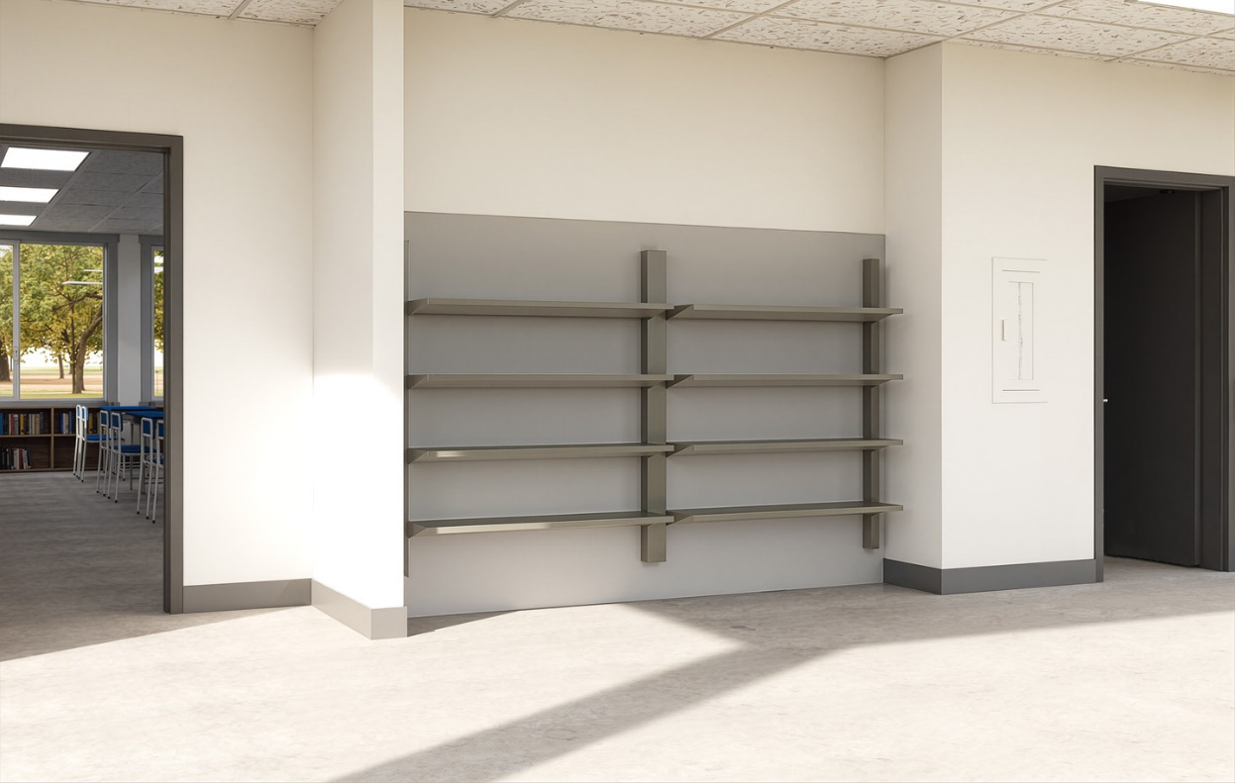
Figure 4: Boot Racks

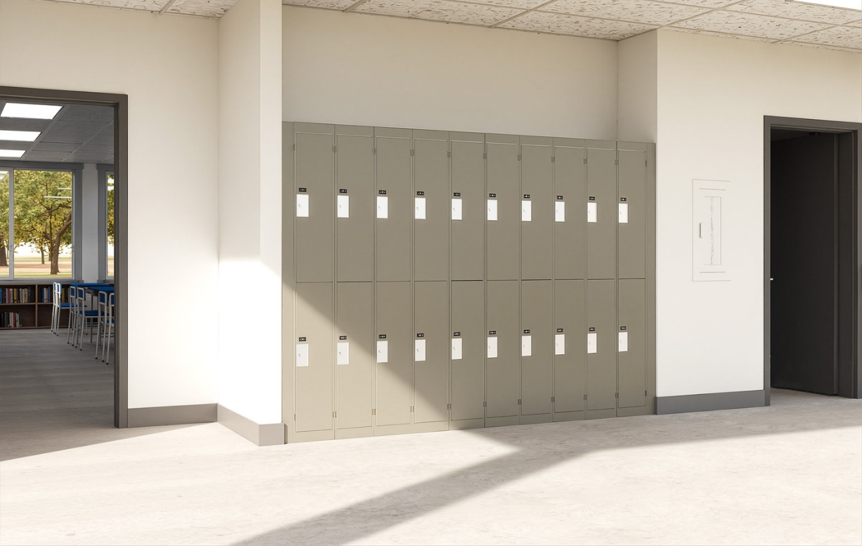
Figure 5: Lockers

